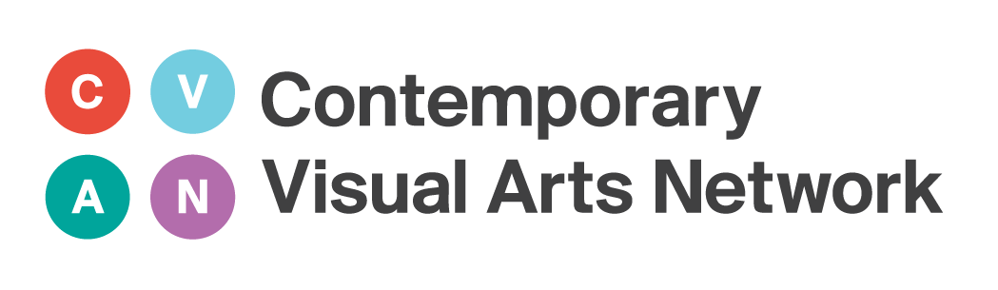

CVAN NW’s Critical Writing Bursary and Workshop Programme

Contemporary Visual Arts Network North West (CVAN NW) is offering 25 writers the opportunity to undertake a programme of six critical writing workshops and be awarded a £300 bursary.

The workshop and bursary programme is delivered in partnership with Manchester Metropolitan University and University of Central Lancashire, through the In Certain Places scheme (www.incertainplaces.org), alongside four leading critical writing platforms in the North West – The Double Negative, Creative Tourist, Art in Liverpool, and Culture on a Shoestring.

Workshops will take place between 11 March and 2 May 2015 (avoiding the Easter break) at venues across the North West on Wednesday afternoons and Saturday mornings. They will be facilitated by specialists in the fields of writing, publication and distribution, both print and online, including Joanne Lee, Chris Sharratt, Bob Dickinson, Gerrie Van Noord, Sophia Crilly and Laura Robertson. The workshop programme will cover key areas in relation to critical writing including form and function, social media, self-distrubution, online and print media, and relationships with galleries.

Each successful applicant will be awarded a bursary of £300 including travel expenses to produce one short exhibition review (1000 – 1200 words) and one feature (2000 – 2500 words). Each will be partnered with a critical writing platform to receive mentoring support and editorial feedback throughout the writing process. Platforms will work closely with writers to determine style and content, though all writing produced must respond to visual arts in the North West region. Writing will be published on one of the four partner platforms and widely promoted across the region and beyond.

Applicants must be aged 18+, and have a genuine passion for and sustained commitment to critical writing for the visual arts in the North West, together with a real desire to develop critical writing skills. We are looking for writers who can make a genuine commitment to attend all six workshops and produce two pieces of writing in the timeframe provided.

This programme forms part of ‘Art: Audience, Development, Discourse and Skills’ (Art: ADDS). Art: ADDS is an Arts Council England funded project initiated by CVAN NW to develop skills, knowledge and expertise in the North West, and to improve the ability of visual arts organisations to build on and increase audiences.

Art: ADDS has three priorities: Critical Writing, Artist Development and Young People. The overarching aims of the Critical Writing programme are to increase the overall quantity and quality of critical writing for the visual arts in the North West, to strengthen the critical writing infrastructure in the region, and to generate new audiences.
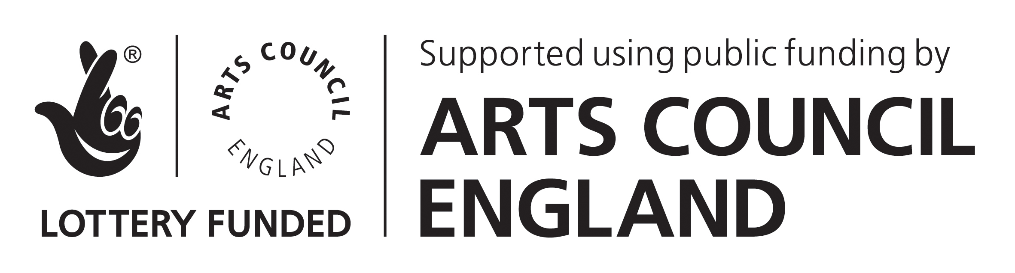

Application Form

Applicants are asked to ensure that they complete all sections of the form electronically.

1. Personal Details
Title (Ms, Miss, Mrs, Mr etc.)
Surname |  |  |  |  | Forename/s
Home Address
 |  | Postcode:
Home tel. |  |  |  |  |  |  | Work tel.
Mobile |  |  |  |  |  |  | Date of Birth
Email Address
Are you currently a student? |  |  |  |  |  | Yes No  (if yes, please provide the following information)
Name of University
Course Title
Current Year of Study

2. Biography
Please summarise your academic and professional experience in no more than 250 words (CVs will NOT be accepted).

3. Previous Critical Writing Experience
Please provide a 500 word extract from a piece of writing you have produced previously.

4. Supporting Statement
Please respond to the following questions in no more than 600 words:
1. Why do you want to participate in this Critical Writing programme? Please describe how it will benefit your career as a writer.
2. What do you understand Critical Writing to be?
3. What is your preferred style of writing and why?
4. Please demonstrate your knowledge of, and sustained commitment to, visual arts in the North West.

5. Access
Is there anything we need to know in order to ensure the programme is fully accessible to you? (For example, do you require a BSL interpreter or wheelchair-access?)

Signature
Date

Please return your completed application form to:
Emma Fry, Art: ADDS Project Coordinator
Email: muralla_emlou@yahoo.com

Deadline for applications: Monday 23 February 2015, 5pm

